**CMR Institute of Technology**

**Kandlakoya Village, Medchal Rd, Hyderabad, Telangana 501401**

**Institute Innovation cell**

**Developing Online Repository of Ideas Developed and Wayforward plan**

**Team Name: *CAMPERS***

***Members***

1. SARIPELLA.SRIKANTH SAI VARMA (20R01A04A8)

2. SHREEKAR REDDY (20R01A04A6)

3. MARGALA.OMPRAKASH (20R01A0492)

4. MOTAM.GANESH (20R01A0495)

5. RASAMALLA.SUMANTH (20R01A04A5)

## *Idea Title* : ROAD BLOCKING SYSTEM AT TOLL GATES

***Problem Statement*** : **PEOPLE TRIES TO ESCAPE FROM TOLL GATES BY DASHING THE BARRIERS.**

# *OVERVIEW :*

In this system Ultrasonic sensor is used to sense the vehicle. And buzzer is used to alert the security officer if driver tries to escape without being checked. Servor motor is used to block the road.

# *GOALS/Objectives :*

1. To stop suspicious vehicles to not cross the toll gates.

# *SPECIFICATIONS* *:*

1.Nobody need to stand at entrance of gate.

2.It automatically stop the vehicle at the entrance.

# *MILESTONES :*

## *Ideation/Data collection :*

Road blocking systems at toll gates to stop the suspicious vehicles.

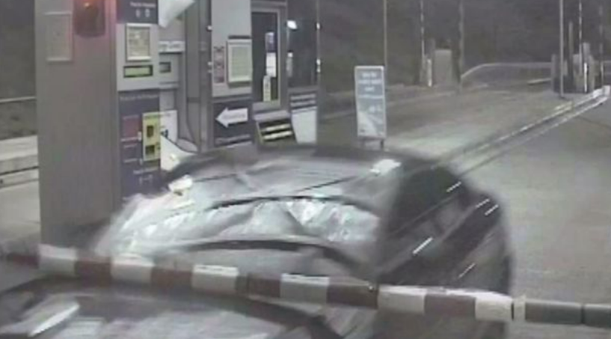

Figure: In this picture man is carrying drugs in car and tries to escape from toll gate by dashing the barrier.

## *Model Building :*

We created the road blocking system can stop suspicious vehicles at toll gate. And this also can use at toll gates to stop the illegal vehicles by crossing the gate

Fig 2 Model or blueprint: ___________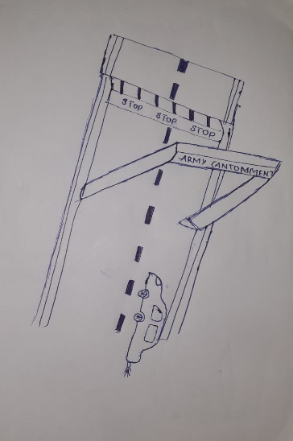__________

## *Components/Tools Understanding and usage :*

1.ARDUINO UNO/CABLE  [**Arduino is an open-source electronics gadget**]

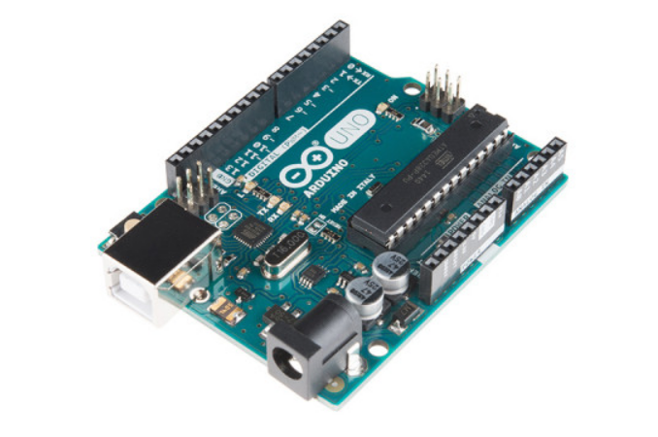

2.SERVOR MOTOR [**used to block the road**]

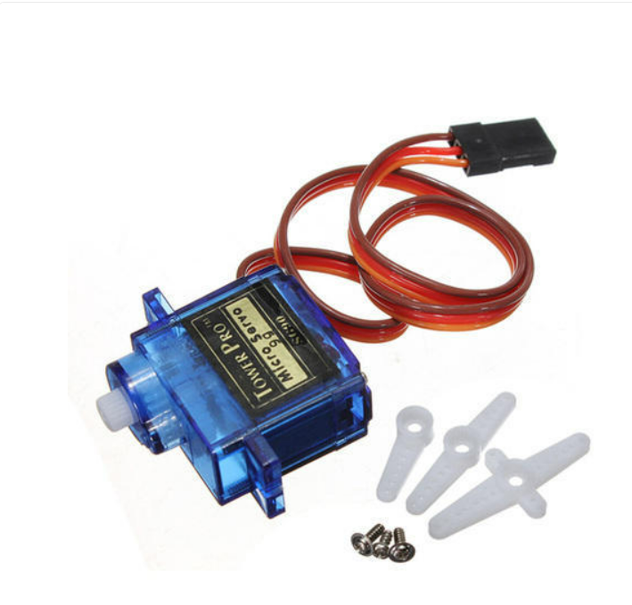

3.ULTRASONIC SENSOR [**measures the distance to an object using ultrasonic sound waves]**

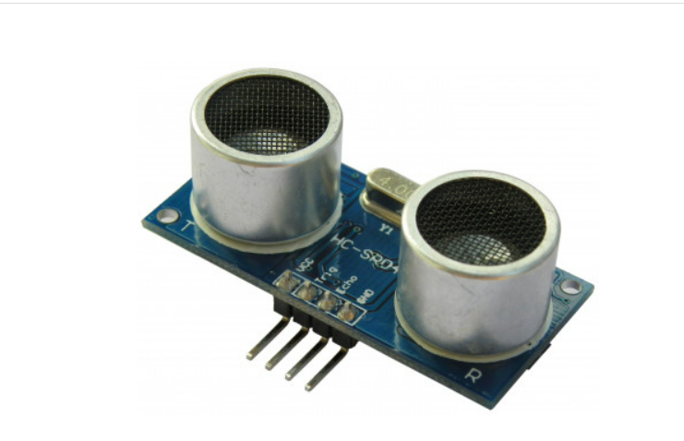

4. BUZZER [ **sound** **alert**]

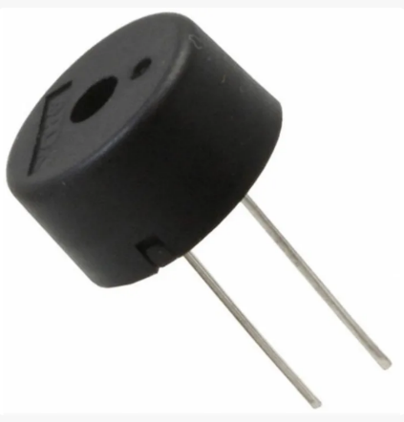

5.9V BATTERY

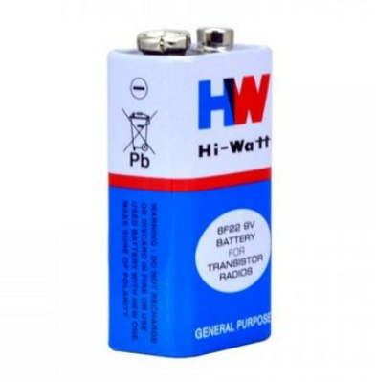

6.BATTERY CONNECTOR[connectir is connected to battery and audino]

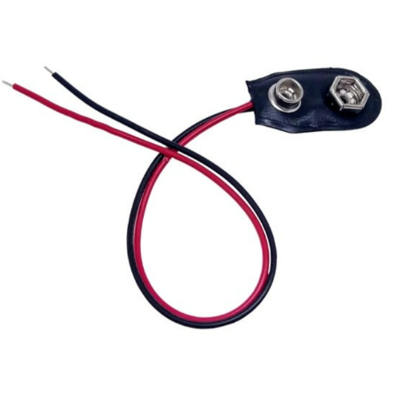

7.SWITCH [**to close the road block barreier**]

